**Project 2 - Scanning for Open ports and Attacking them:**

**Task 1:**Login to metaspolit and extract ip address

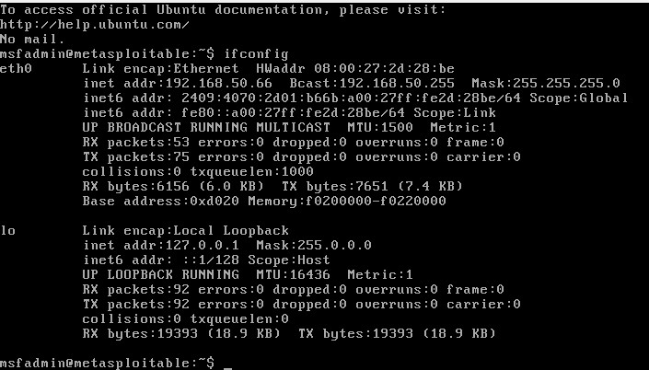

**Task 2:** Do nmap scanning on the IP, Extract Open port and Version Details

Command: nmap -sV 192.168.50.66

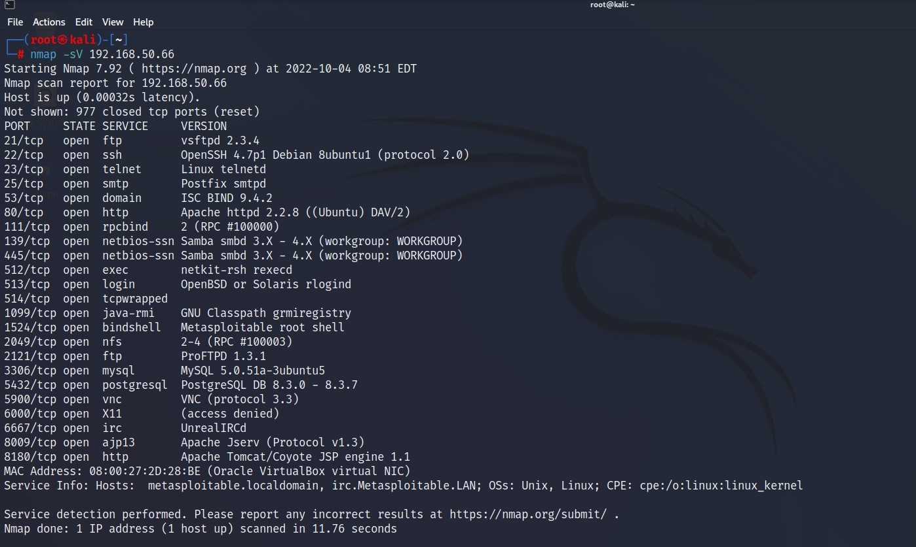

**Task 3:**Check the vulnerable version exploitation's procedure in rapid7 and start exploiting the following ports  
A)Telnet  
B)FTP  
C)SSH

A)Telnet

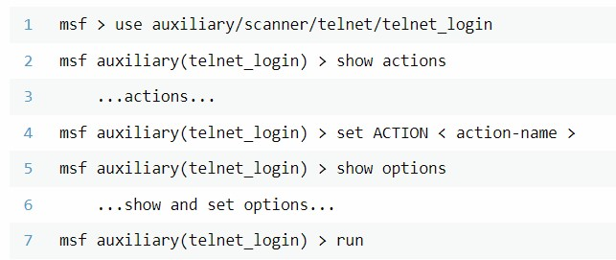

Image - 1

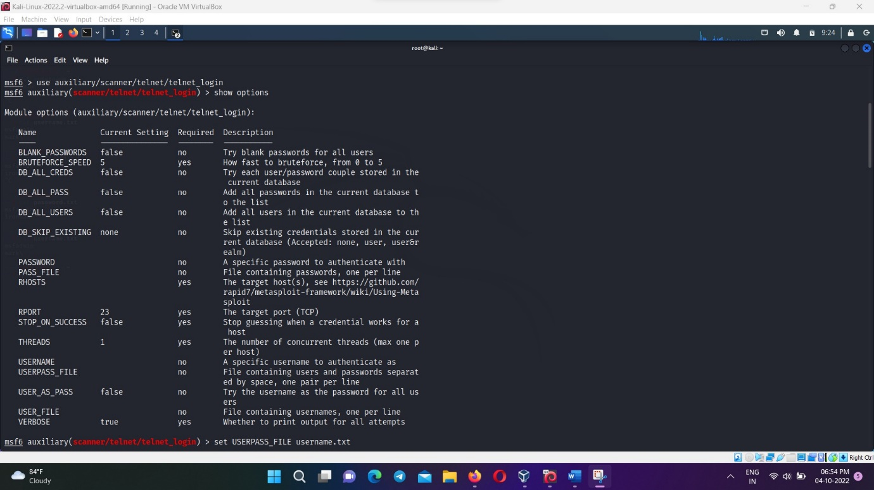

Image -2

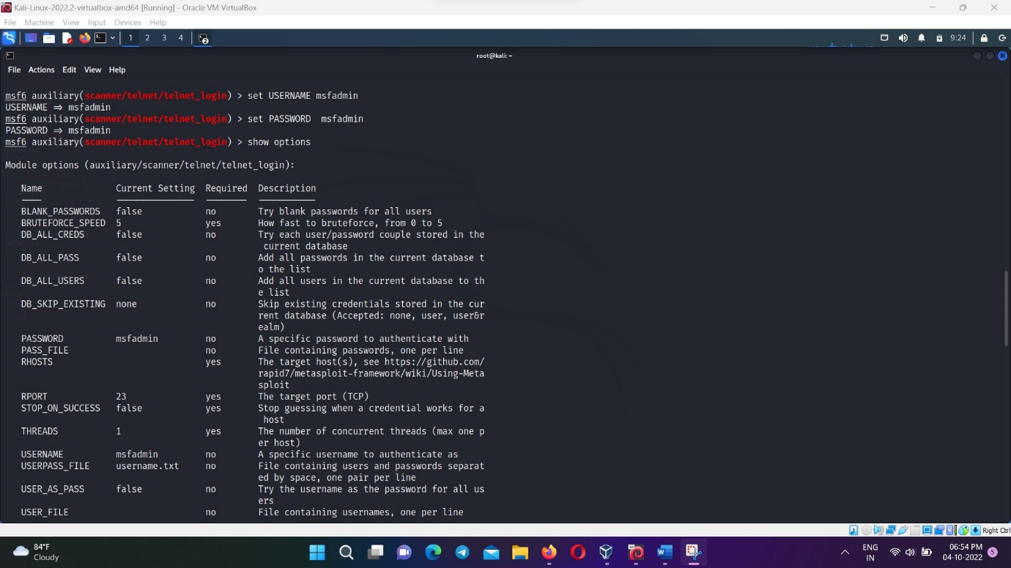

Image -3

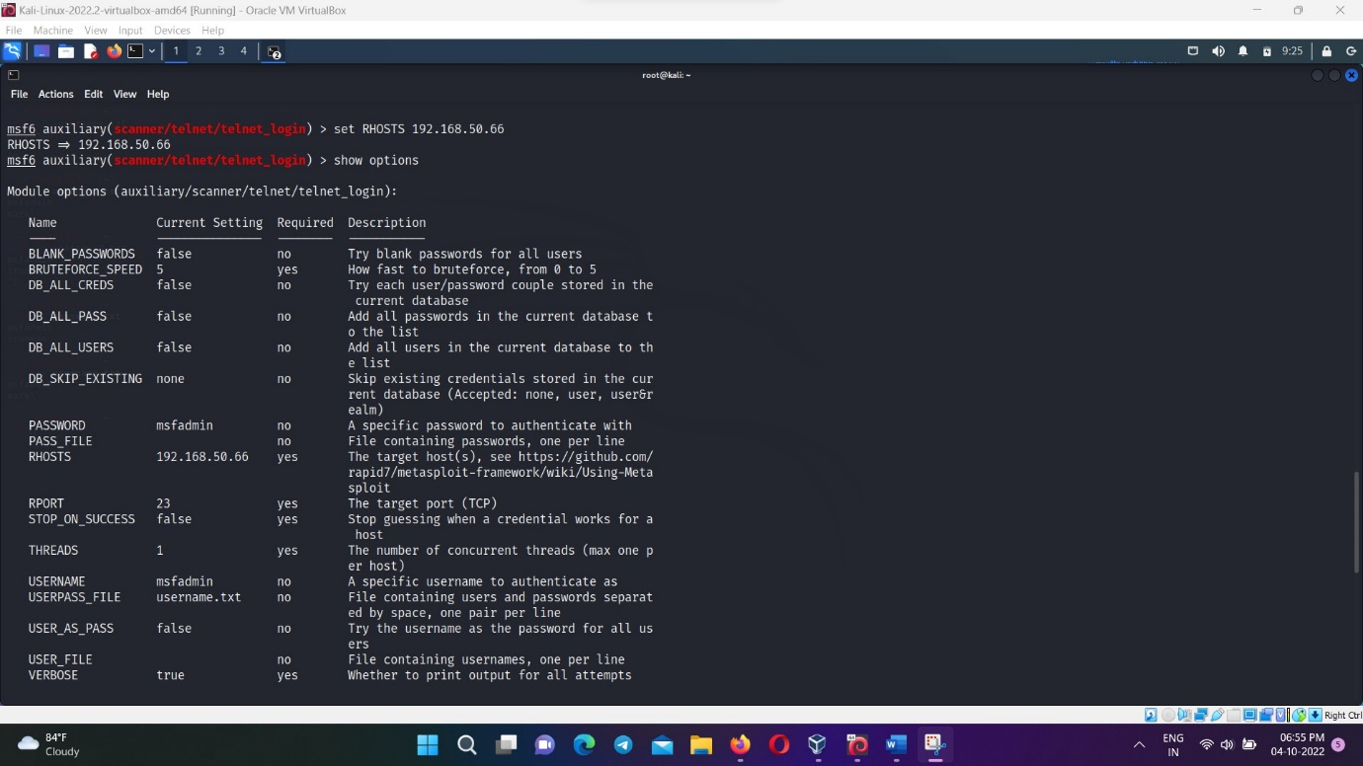

Image -4

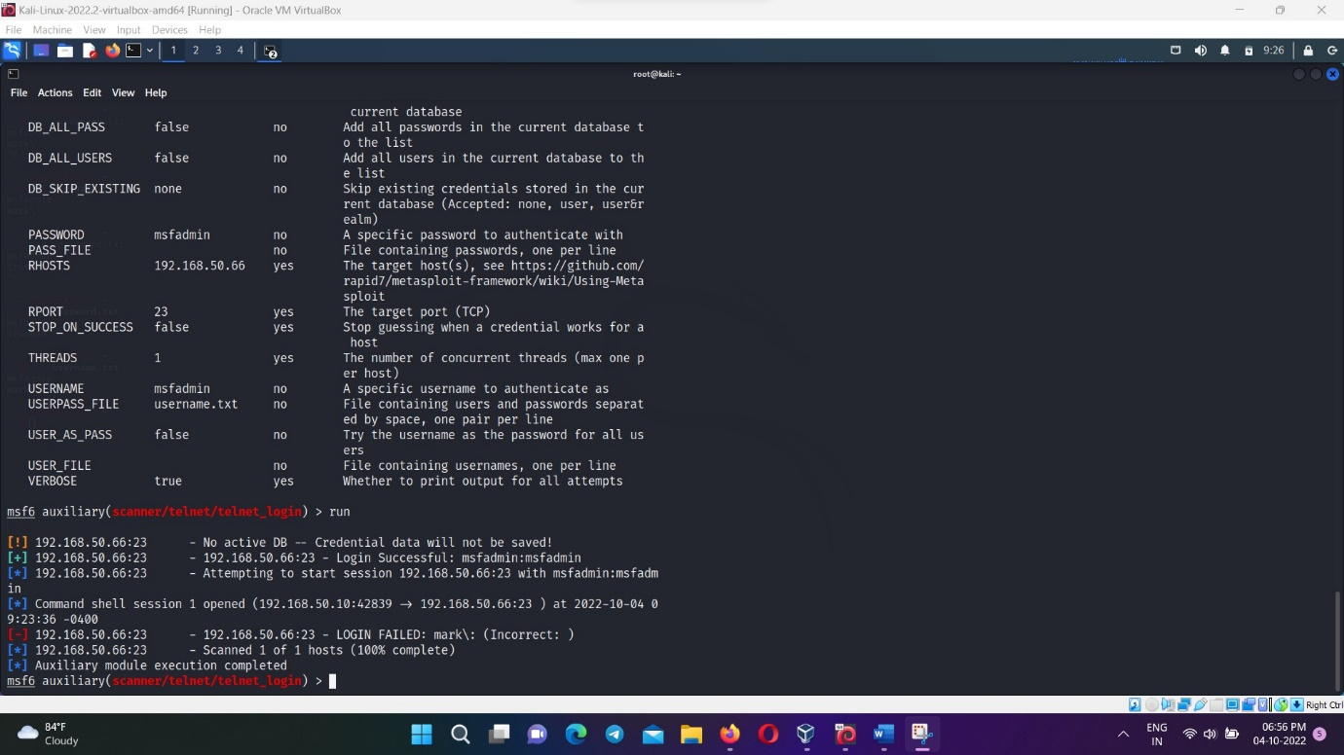

B)FTP

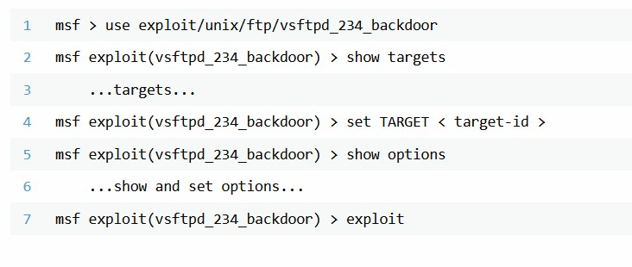

Image -1

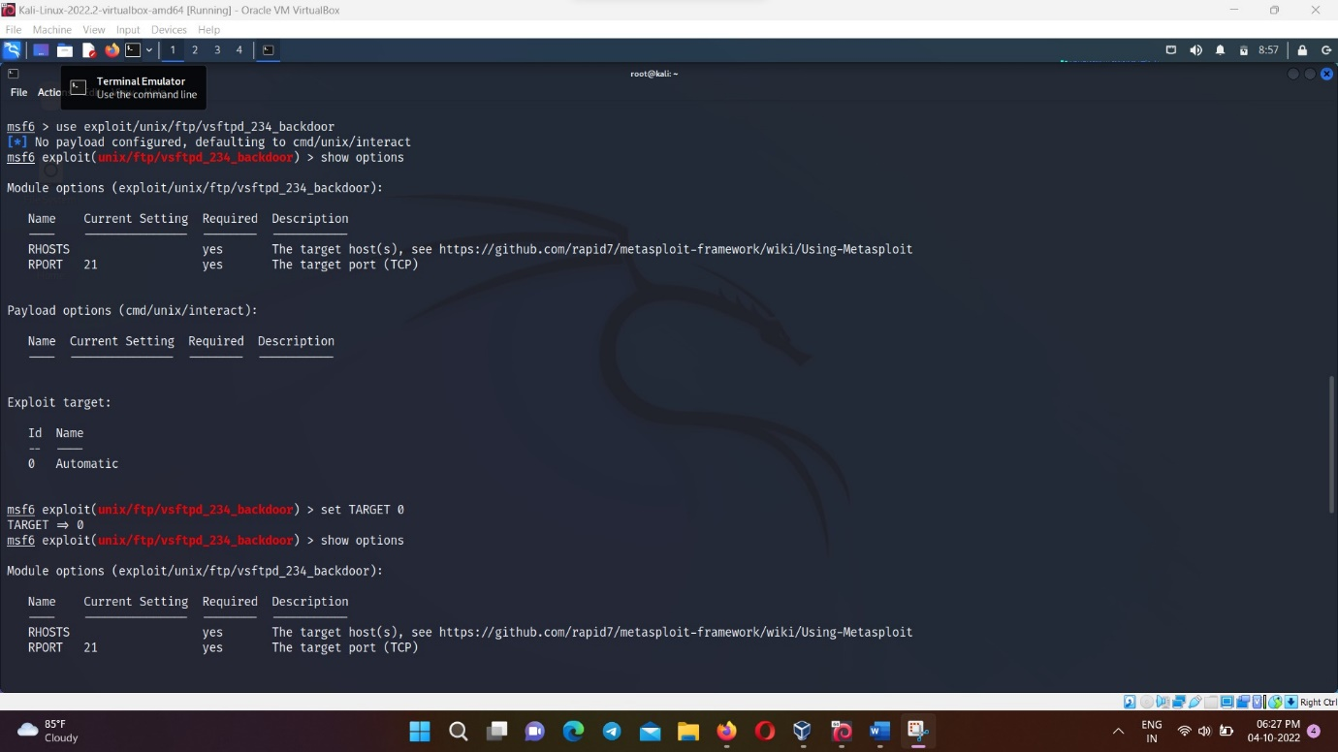

Image -2

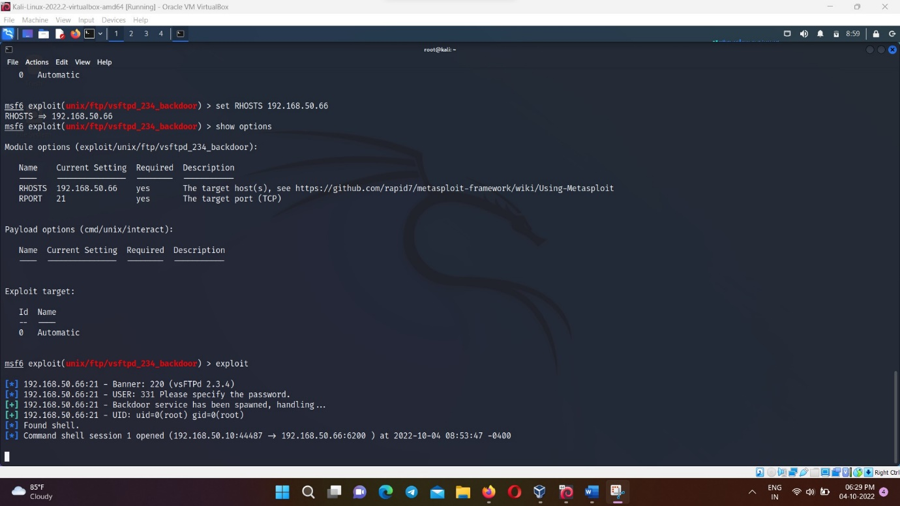

C)SSH

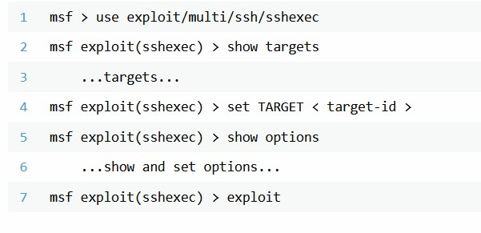

Image -1

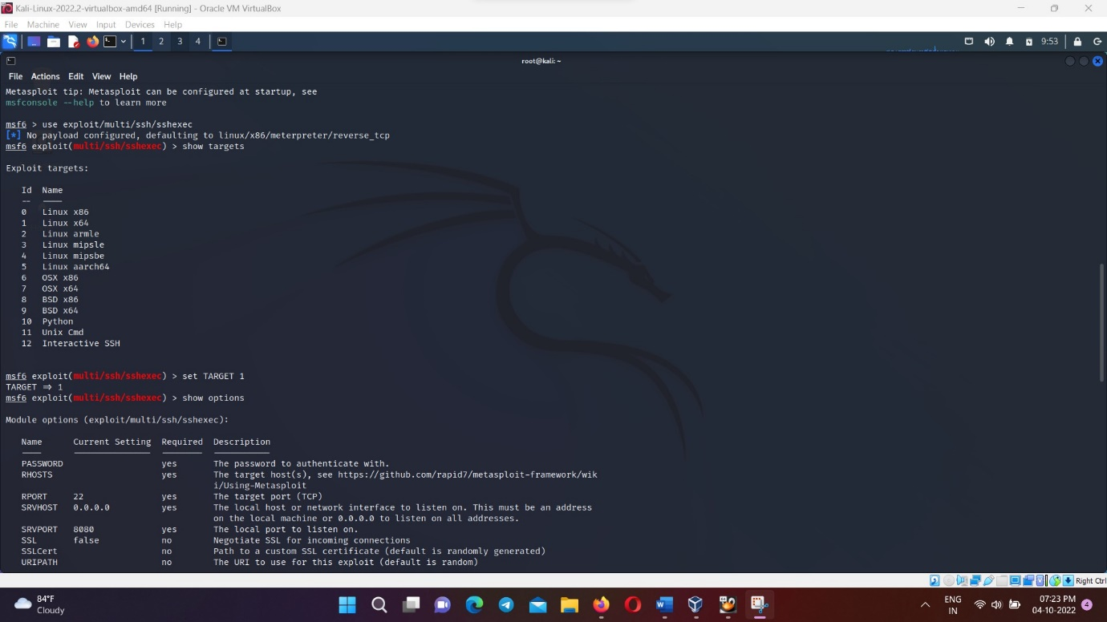

Image -2

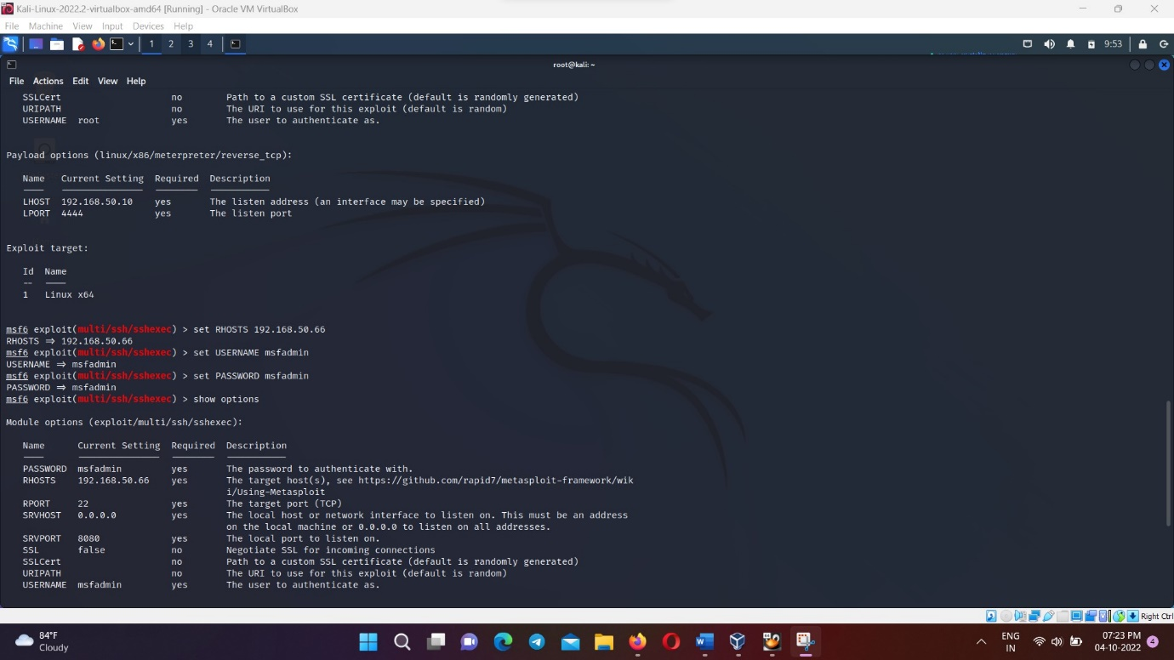

Image -3

